Introduction

The objective of this lab is to introduce you to controlling the design and layout of web pages using CSS.

For each web page, try to just look at the picture in the book and then make your web page look like the picture. Look at the step-by-step instructions if you run into difficulty. If you have any questions or comments be sure to post them in the Q and A Forum.

Part 1

1. **Tutorial 4:** Do the tutorial exercise on pages 221 through 303 of your textbook to create the *Cycle Pathology* web site
2. **Review:** Create the *Cycle Pathology Tour Page* on pages 304 – 306 of your textbook. Again, it’s best to just look at the picture of the completed page and write HTML code to make a web page that looks just like the picture.

**Best Practice**: Make the web page by just looking at the pictures of the completed pages (shown at the end of this document) and then trying to write HTML that makes a web page look just like the picture. If you run into difficulty, then look at the step by step instructions. In “real life” you wouldn’t have step by step instructions.

Part 2

Do any one of the case problems, 1 – 3, for Tutorial 4.

Submitting your lab work

1. Zip the tutorial.04 folder along with its tutorial, review, and case subfolders.
2. Upload your tutorial.04.zip file using the *Production Version* assignment link on Moodle
3. Use an FTP client to publish your web site to citstudent web server.

Picture of the completed tutorial web site

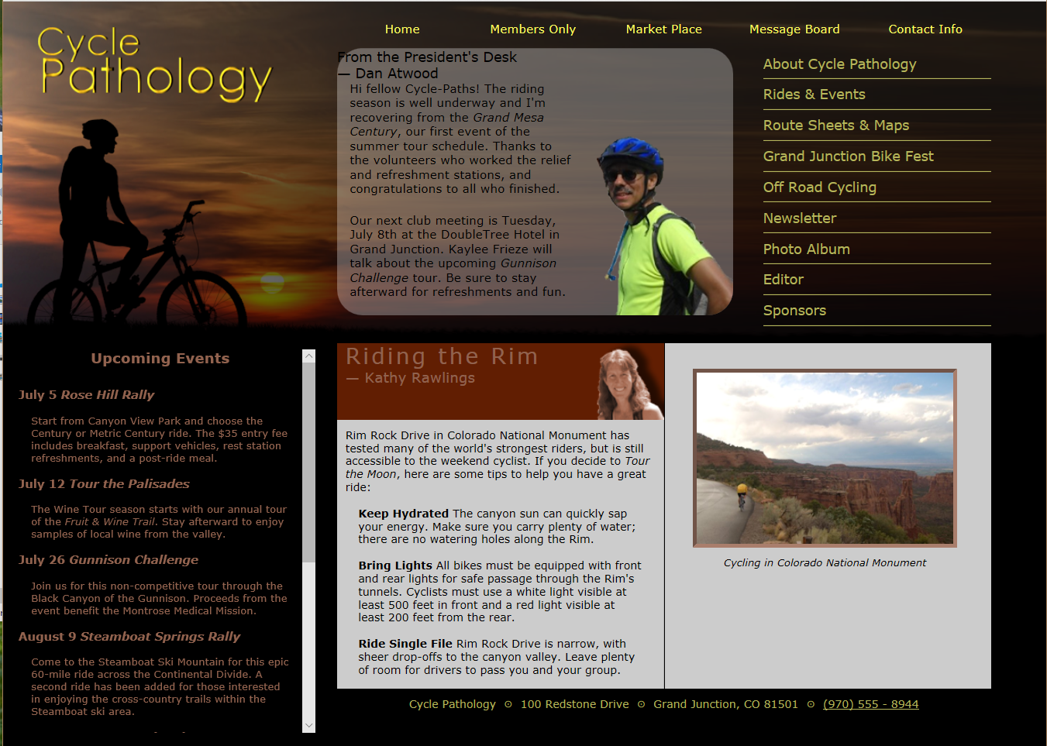

Picture of the completed review web site

